**AI ASSISTED CODING **

***LAB-1.4: Environment setup-GitHub copilot and VS Code Integration***

**Roll no: -2503A51L06**

**Name: -**D.Nagamrutha

**Batch: -** 25BTCAICSB19

**Task#1:**

**Prompt:** Function to check if a string is a valid palindrome (ignoring spaces and case).

**Code Generated:**

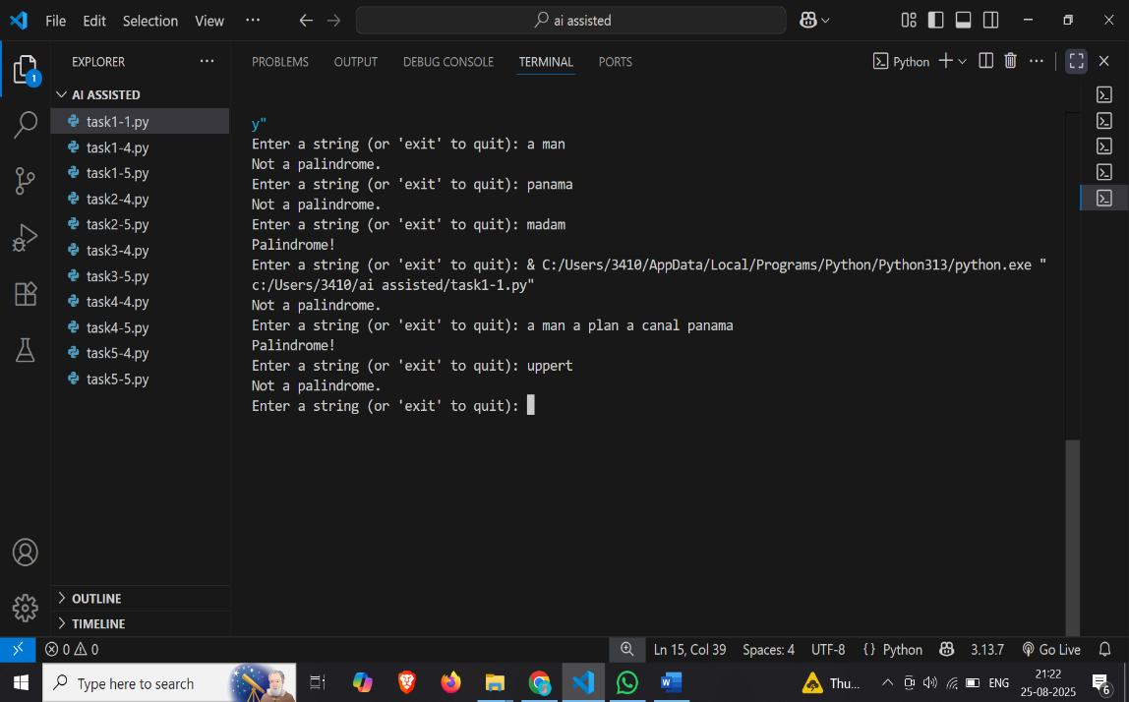**Output:**

**Observation:**

This Python program checks if a given string is a palindrome while ignoring spaces, cases, and non-alphanumeric characters. It repeatedly asks the user for input until they type “exit. “For each input, it cleans the string, compares it with its reverse, and then prints whether it isa palindrome or not.

**TASK#2:**

**Prompt:** Python function that returns the Fibonacci sequence up to n terms.

**Code Generated:**

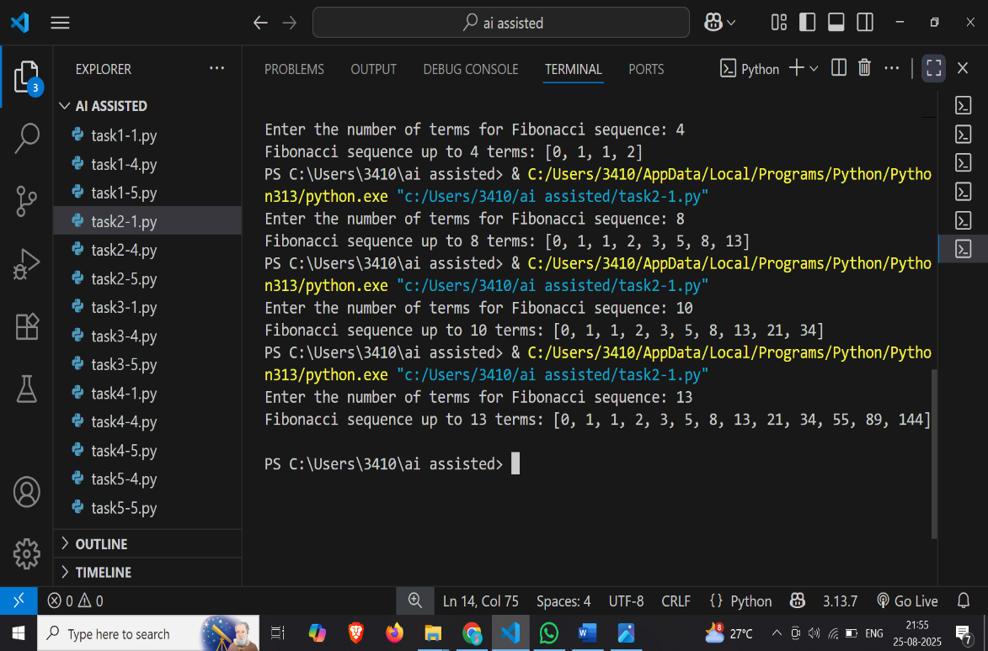 **Output:**

**Observation:**

This Python program generates the Fibonacci sequence up to a user-specified number of terms. It uses a loop to calculate each term by adding the two previous numbers, starting from 0 and 1, and stores them in a list. The program then prints the complete sequence based on the number of terms entered by the user.

**Task#3:**

**Prompt:** generate a code / function that reverses a string.

**Code Generated:** 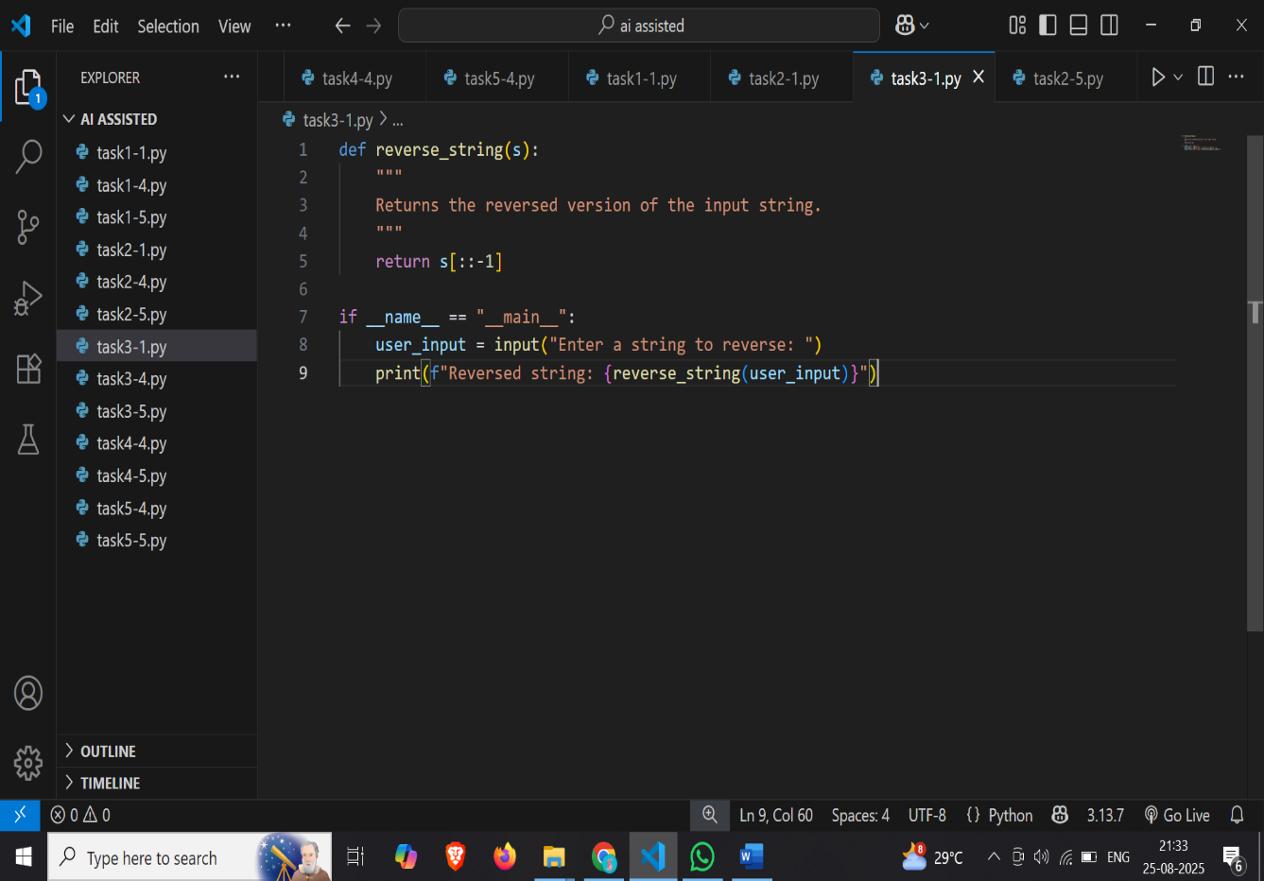

**Output:**

**Observation:**

This Python program takes a string input from the user and returns its reversed form. It defines a function that uses slicing to reverse the string, and then prints the reversed result after the user enters their text.

**TASK#4:**

**Prompt:** Generate a program that simulates a basic calculator (add, subtract, multiply, divide).

**Code Generated:**

**Output:**

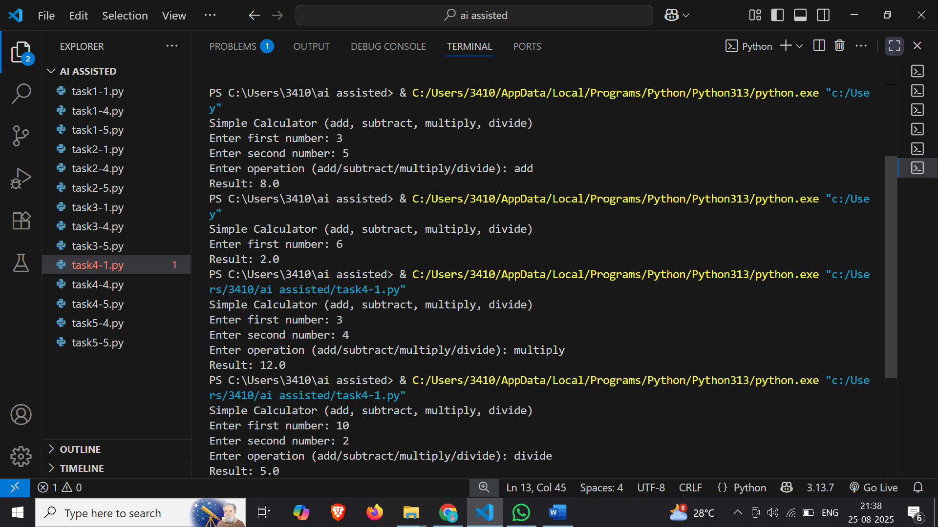

**Observation:**

This Python program works as a simple calculator that performs addition, subtraction, multiplication, and division based on user input. It takes two numbers and an operation choice from the user, processes the calculation, and displays the result. The program also handles division by zero by showing an error message instead of crashing**.**

**Task#5:**

**Prompt:** write a function that reads a file and returns the number of lines.

**Code Generated:**

**Output:**

**File:**

**Observation:**

This Python program counts the number of lines in a given file. It asks the user for a filename, reads the file, and then returns the total line count. However, the code has a small error: "sample.txt" should be replaced with the variable filename inside the open () function.